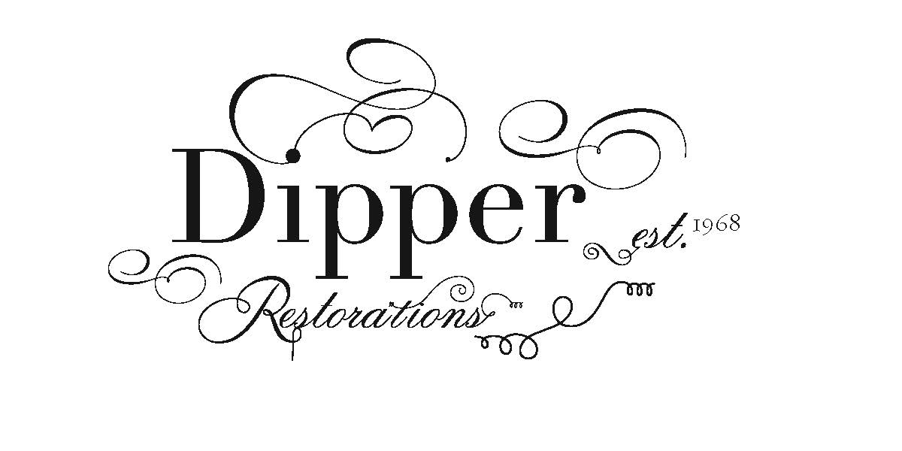
Boston Early Music Festival– June 11-14, 2025

Baroque Violins

TDV23173 | Violin: Baroque, North Germany c. 1808 | $11,000.00
DV350 | Violin: Baroque, Klingenthal, c. 1790 | $12,000.00
DV359 | Violin: Baroque, Scandinavian Origin, c. 1760-1780 | $14,000.00
V1103 | Violin: Baroque, Snoeck School, Brussels c. 1710 | $19,000.00
DV349 | Violin: Baroque, Mathias Hornsteiner, Mittenwald 1788 | $23,000.00
DV354 | Violin: Baroque, J. Thompson, London 1778 | $24,000.00
DV325 | Violin: Baroque, Hermann Joseph Stoss, Fussen 1729 | $26,000.00

Classical Violins

DV351 | Violin: Classical, Joseph Bonel, Rennes c. 1830 | $11,000.00

1201 Marquette Avenue | Suite 150-A | Minneapolis, MN 55403
Toll-Free: 800.279.4323 | Phone: 612.375.0750 | Fax: 612.375.0096
E-mail: adipper@dipperrestorations.com | www.dipperrestorations.com

Boston Early Music Festival– June 11-14, 2025

Violin Bows – imported

DVB471 | Baroque - Imported - Snakewood | $475.00
DVB472 | Baroque - Imported - Snakewood | $475.00
DVB475 | Baroque - Imported - Snakewood | $475.00

Violin Bows – baroque

DVB79 | Violin Bow: Baroque, A. Dipper, Short Corrette model | $2,300.00
DVB477 | Violin Bow: Baroque, A. Dipper, Renaissance Ratchet | $2,400.00
DVB479 | Violin Bow: Baroque, A. Dipper, Renaissance Ratchet | $2,400.00
DVB386 | Violin Bow: Baroque, A. Dipper, Corrette model | $2,900.00
DVB466 | Violin Bow: Baroque, A. Dipper, Corrette model | $2,900.00
DVB467 | Violin Bow: Baroque, A. Dipper, Corrette model | $2,900.00
DVB437 | Violin Bow: Baroque, A. Dipper, Strad 1720 model | $3,200.00
DVB456 | Violin Bow: Baroque, A. Dipper, Roda model | $3,300.00
DVB450 | Violin Bow: Baroque, A. Dipper, Roda model | $3,300.00
DVB451 | Violin Bow: Baroque, A. Dipper, Roda model | $3,300.00
DVB482 | Violin Bow: Baroque, A. Dipper, Strad Museo del Violino | $3,400.00

Violin Bows – classical

DVB430 | Violin Bow: Classical, A. Dipper, Tartini model | $2,200.00
DVB343 | Violin Bow: Classical, A. Dipper FX Tourte, Cramer | $3,200.00
DVB458 | Violin Bow: Classical, A. Dipper, Paganini model | $3,200.00
DVB487 | Violin Bow: Classical, A. Dipper, Viotti model | $3,400.00
DVB489 | Violin Bow: Classical, A. Dipper, Viotti model | $3,400.00
DVB484 | Violin Bow: Classical, A. Dipper, Duchene model | $3,600.00
DVB366 | Violin Bow: Classical, A. Dipper, Paganini Model, inlay | $5,800.00

1201 Marquette Avenue | Suite 150-A | Minneapolis, MN 55403
Toll-Free: 800.279.4323 | Phone: 612.375.0750 | Fax: 612.375.0096
E-mail: adipper@dipperrestorations.com | www.dipperrestorations.com

Boston Early Music Festival– June 7-10, 2023

Viola Bows – imported

DVAB194 | Viola Bow: Baroque – Imported - Snakewood | $570.00
DVAB195 | Viola Bow: Baroque – Imported - Snakewood | $570.00

Viola D’Amore Bows – baroque

DVAB198 | Viola d’Amore Bow: Baroque, A. Dipper, Corrette model | $1,800.00
DVAB199 | Viola d’Amore Bow: Baroque, A. Dipper, Corrette model | $1,800.00

Viola Bows - Baroque
DVAB190 | Viola Bow: Baroque, A. Dipper, Corrette model | $2,900.00
DVAB183 | Viola Bow: Baroque, A. Dipper, Corrette model | $2,900.00
DVAB191 | Viola Bow: Baroque, A. Dipper, Corrette model | $2,900.00
DVAB203 | Viola Bow: Baroque, A. Dipper, Corrette model | $2,900.00
DVAB197 | Viola Bow: Baroque, A Dipper, P. Tourte model | $3,400.00
DVAB192 | Viola Bow: Baroque, A. Dipper, Strad Model w/pointille work | $3,800.00
DVAB177 | Viola Bow: Baroque, A. Dipper, Strad Model w/pointille work | $3,800.00
DVAB176 Viola Bow: Baroque, A. Dipper, Pike head P. Tourte model $4,200.00

Viola Bows – classical

DVAB196 | Viola Bow: Classical, A. Dipper, English Model | $3,200.00

1201 Marquette Avenue | Suite 150-A | Minneapolis, MN 55403
Toll-Free: 800.279.4323 | Phone: 612.375.0750 | Fax: 612.375.0096
E-mail: adipper@dipperrestorations.com | www.dipperrestorations.com

Boston Early Music Festival– June 7-10, 2023

cello Bows – imported

DCLB134 | Cello Bow: Baroque - Imported - Snakewood | $750.00
DCLB135 | Cello Bow: Baroque – Imported - Snakewood | $750.00
cello Bows – baroque

DCLB133 | Cello Bow: Baroque, A. Dipper, French 1760 violoncello piccolo | $3,200.00
DCLB128 | Cello Bow: Baroque, A. Dipper, Pierre Tourte model | $3,600.00
DCLB129 | Cello Bow: Baroque, A. Dipper, Pierre Tourte model | $3,600.00
DCLB132 | Cello Bow: Baroque, A. Dipper, Dodd model | $3,600.00

cello Bows – classical

XDCLB2415 | Cello Bow: Classical, A. Dipper, English, Cramer model | $3,800.00

1201 Marquette Avenue | Suite 150-A | Minneapolis, MN 55403
Toll-Free: 800.279.4323 | Phone: 612.375.0750 | Fax: 612.375.0096
E-mail: adipper@dipperrestorations.com | www.dipperrestorations.com

